Day 14: Analyze Data with NumPy Part - 1
You are given the following data, which is in list format: Your task is to analyze and obtain insights from this data using NumPy (do not use pandas). Your first task is to create one array from the three (3) lists. You will use this array to answer the questions that follow.
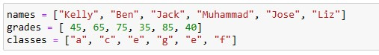
- Using NumPy, write code that returns all the names and the number of students from class "e" who got over 50 marks.
- Your next task is to write a code that returns all the students who got less than 75 marks.
- Write code that returns how many marks a student named Liz got.
- Which student got the highest marks?
- What is the longest name in the array, and what is its index?

